EXPERIMENT – 4 AND 5:

Practicing DDL Commands(Data Defination Language)

* CREATE TABLE Command
* ALTER TABLE Command
* TRUNCATE TABLE Command
* DROP TABLE Command

CREATE TABLE Command:

use mydb;

CREATE TABLE Persons (PersonID numeric(20 key) primary , Last_Name varchar(20),

FirstName varchar(20),City varchar(55));

Desc Persons;

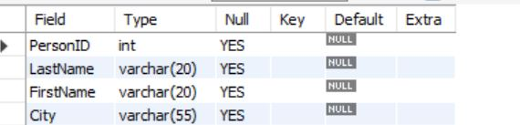

ALTER TABLE Command: -

ALTER TABLE Persons add Adrress varchar(100);



DROP TABLE Command:-

DROP TABLE Persons; 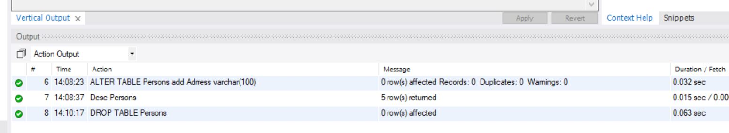

TRUNCATE TABLE Command:-

CREATE TABLE Students( First_Name varchar(20), Last_Name varchar(20) , Pin_No varchar(20) primary key ,Dept varchar(30));

TRUNCATE TABLE Students;

